Sorry, I stuck in here, I can’t find the “Welcome to” under the <h1> tag, I can only find out the <h2> tag.

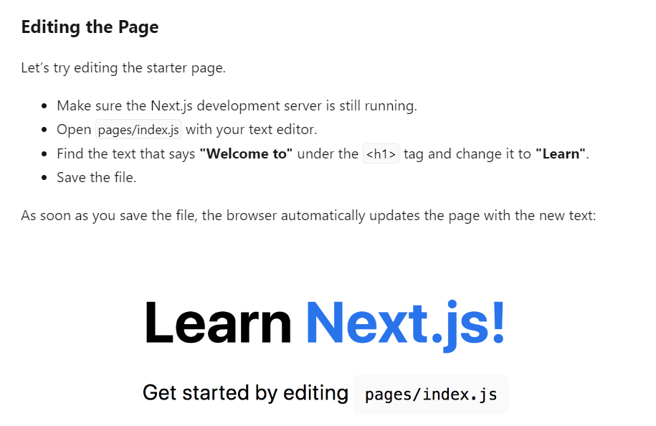

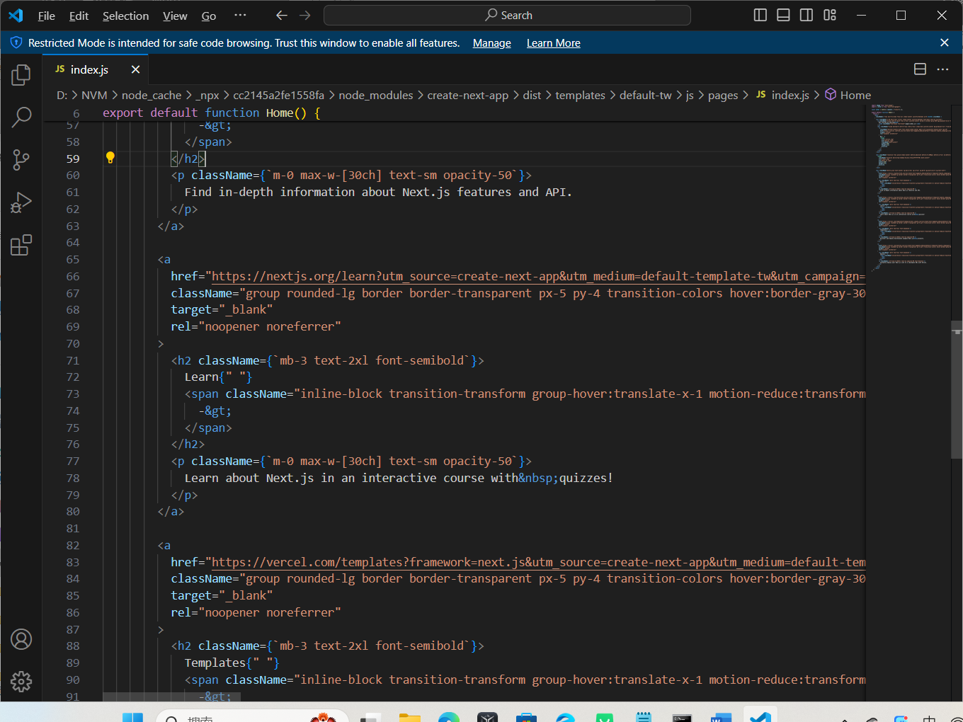

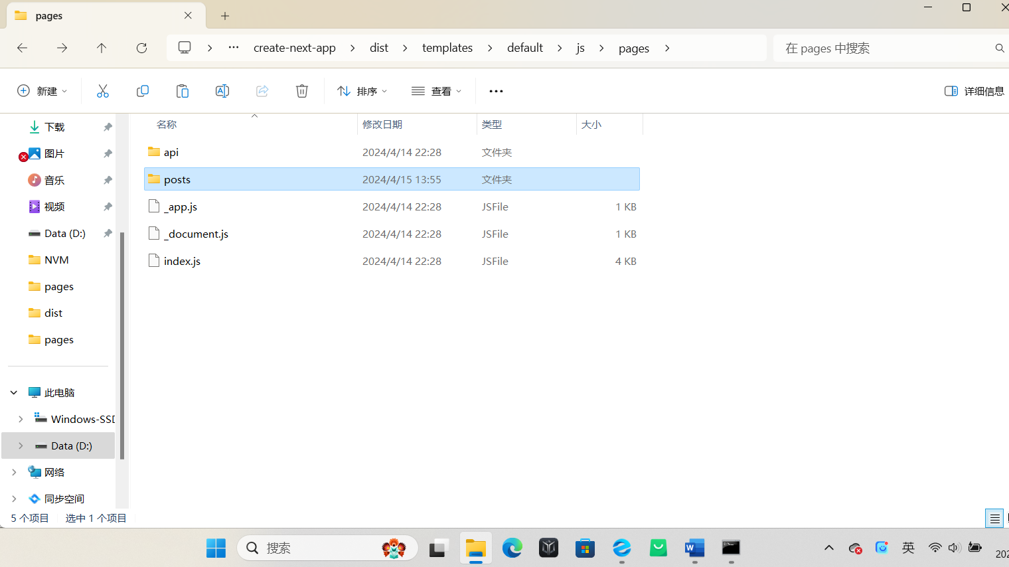

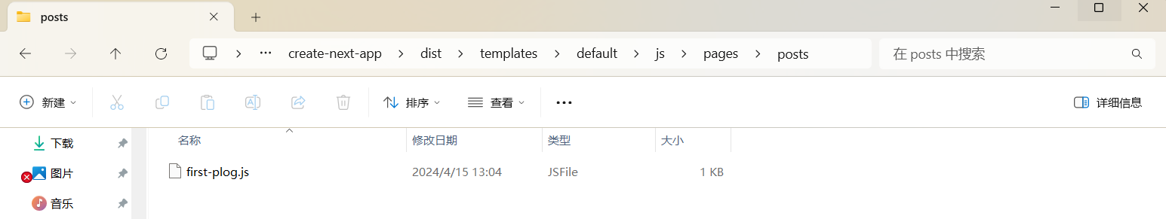

I follow the instruction but it doesn’t work, I still can’t find the way to solve it.